1

Quick primer Deep Learning and Introduction to GAN

Recently with the progress of generative models, neural networks can not only recognize images, but they can be used to generate audio and realistic images as well.

In this chapter, we will look at various concepts and terminology related to deep learning as a refresher. Then we will deep dive into the creative nature of deep learning through latest state of the art algorithm of Generative Adversarial Network, commonly known as GAN. You will learn through hands-on example to use the generative ability of the neural networks in generating realistic images from various real-world datasets (such as mnist and cifar). Also, you will understand how to overcome the major challenge of unsupervised learning with deep networks using semi-supervised approach and apply it to your own problem domain. In the final section of this chapters, you will learn some of the training obstacle followed by practical tips and tricks of working with GAN models.

We will cover the following topics in this chapter:

* Deep Learning and related concepts- ConvNet, RNN, LSTM, etc
* What is GAN? Its application, tips and tricks
* Explaining the concept of GAN through 2-layer Neural Network Image Generation with Tensorflow
* Image generation with Deep Convolutional GAN (DCGAN) using Keras

Implementation of Semi-Supervised Learning using Tensorflow

# Evolution of Deep Learning

A lot of the important work on neural networks happened in the 80's and in the 90's, but back then computers were slow and datasets very tiny. The research didn't really find many applications in the real world. As a result, in the first decade of the 21st century neural networks have completely disappeared from the world of machine learning. It's only in the last few years, first seeing speech recognition around 2009, and then in computer vision around 2012, that neural networks made a big comeback with (LeNet, AlexNet). What changed?

Lots of data (Big Data) and cheap, fast GPU’s. Today, neural networks are everywhere. So, if you're doing anything with data, analytics or prediction, deep learning is definitely something that you want to get familiar with.

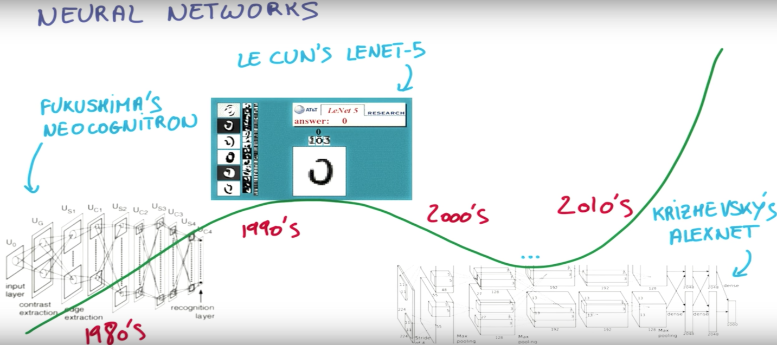

**Figure-1:** Evolution of Deep Learning

B08086_01_01.png

Deep learning is an exciting branch of machine learning that uses data, lots of data, to teach computers how to do things only humans were capable of before like recognizing what's in an image, what people are saying when they are talking on their phone, translating a document into another language, helping robots explore the world and interact with it. Deep learning has emerged as a central tool to solve perception problems and it's the state of the art with computer vision and speech recognition.

Today many companies have made deep learning a central part of their machine learning toolkit- Facebook, Baidu, Amazon, Microsoft, and Google are all using deep learning in their products because deep learning shines wherever there is lots of data and complex problems to solve. Let’s get familiarize with some deep neural network concepts and terminology.

## Rectified Linear Unit- RELU

A neural network can be built from combining some linear classifier with some non-linear function. The Rectified Linear Unit has become very popular in the last few years. It computes the function f(x) = max(0,x) f(x)=max(0,x). In other words, the activation is simply thresholded at zero. Unfortunately, ReLU units can be fragile during training and can “die” as a ReLU neuron could cause the weights to update in such a way that the neuron will never activate on any datapoint again and so the gradient flowing through the unit will forever be zero from that point on.

To overcome this problem a Leaky ReLU function will have a small negative slope (of 0.01, or so) instead of zero when x<0. f(x)=𝟙(x<0)(αx)+𝟙(x>=0)(x)f(x)=1(x<0)(αx)+1(x>=0)(x) where αα is a small constant.

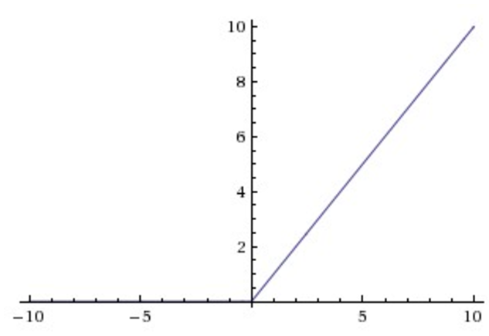

**Figure-2:** Rectified Linear Unit

B08086_01_02.png

## Learning Rate

Learning rate tuning can be very strange. For example, you might think that using a higher learning rate means you learn more or that you learn faster. That's just not true. In fact, you can often take a model, lower the learning rate and get to a better model faster.

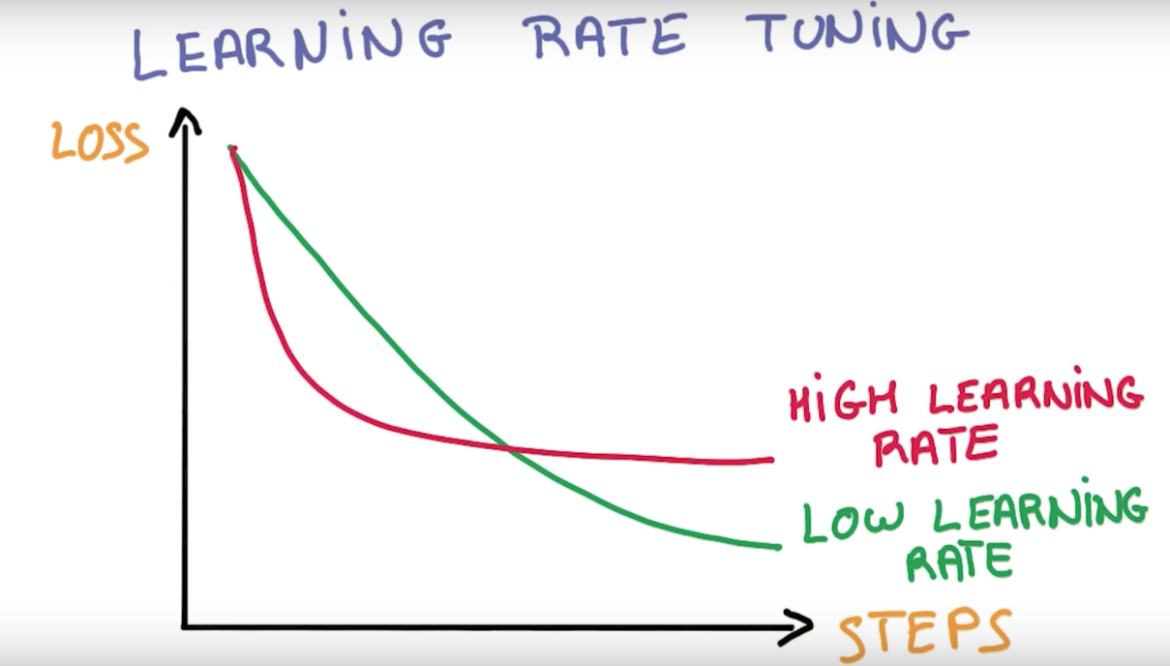

**Figure-3:** Learning Rate

B08086_01_03.png

You might be tempted to look at the learning curve that shows the loss over time to see how quickly the network learn. Here the higher learning rate starts faster, but then it plateaus, whereas the lower learning rate keeps on going and gets better. It is a very familiar picture for anyone who has trained neural networks. “Never trust how quickly you learn”.

## Stochastic Gradient Decent-SGD

Scaling batch gradient descent is cumbersome because it has to compute a lot if the dataset is big and as a rule of thumb. If computing your loss takes n floating point operations, computing its gradient takes about three times that compute.

But in practice we want to be able to train lots of data because on real problems we will always get more gains the more data we use. And because gradient descent is intuitive, and have to do that for many steps. So, that means that in-order to update the parameters in single step, it has to go through all the data samples and then doing this iteration over the data tens or hundreds of times.

Instead of computing the loss over entire data samples for every step, we're can compute the average loss for a very small random fraction of the training data. Think between 1 and 1000 training samples each time. This technique is called Stochastic gradient descent (SGD) and is at the core of deep learning. That's because stochastic gradient descent scales well with both data and model size.

SGD gets its reputation for being black magic as it has lots of hyper-parameters to play and tune such as initialization parameters, learning rate parameters, decay, momentum and you have to get them right.

AdaGrad is a simple modification of SGD which implicitly does momentum and learning rate decay by itself. Using AdaGrad often makes learning less sensitive to hyper-parameters. But it often tends to be a little worse than precisely tuned SDG with momentum. It's still a very good option though, if you're just trying to get things to work.

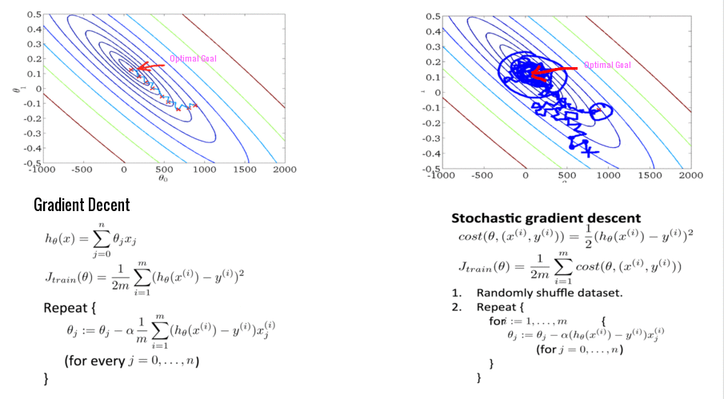

**Figure-4:** Loss computation in batch gradient decent and SGD

Source- <https://www.coursera.org/learn/machine-learning/lecture/DoRHJ/stochastic-gradient-descent>

B08086_01_04.png

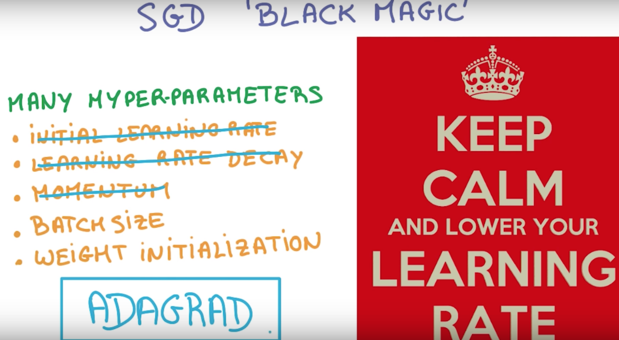

**Figure-4:** Stochastic Gradient decent and AdaGrad

B08086_01_05.png

You can notice from the Figure-4 above that in case of batch gradient decent the loss/optimization function is well minimized, whereas SGD calculates the loss by taking random fraction of the data in each step and often oscillates around that point. and SGD often converges faster.

## Regularization

The first way to prevent over fitting is by looking at the performance under validation set, and stopping to train as soon as it stops improving. It's called early termination, and it's still the best way to prevent neural network from over-optimizing on the training set. Another way is to apply regularization. Regularizing means applying artificial constraints on the network that implicitly reduce the number of free parameters while not making it more difficult to optimize.

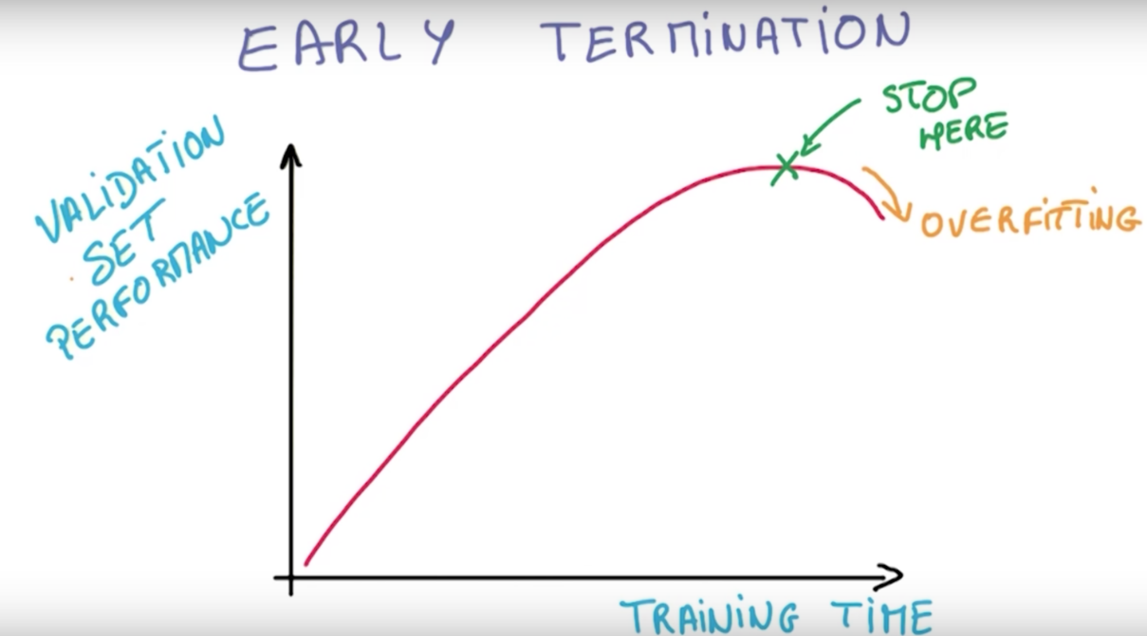

**Figure-6a:** Early Termination

B08086_01_06.png

In the skinny jeans analogy as shown in Figure-6b, think stretch pants. They fit just as well, but because they're flexible, they don't make things harder to fit in. The stretch pants of deep learning are sometime called L2 Regularization. The idea is to add another term to the loss, which penalizes large weights.

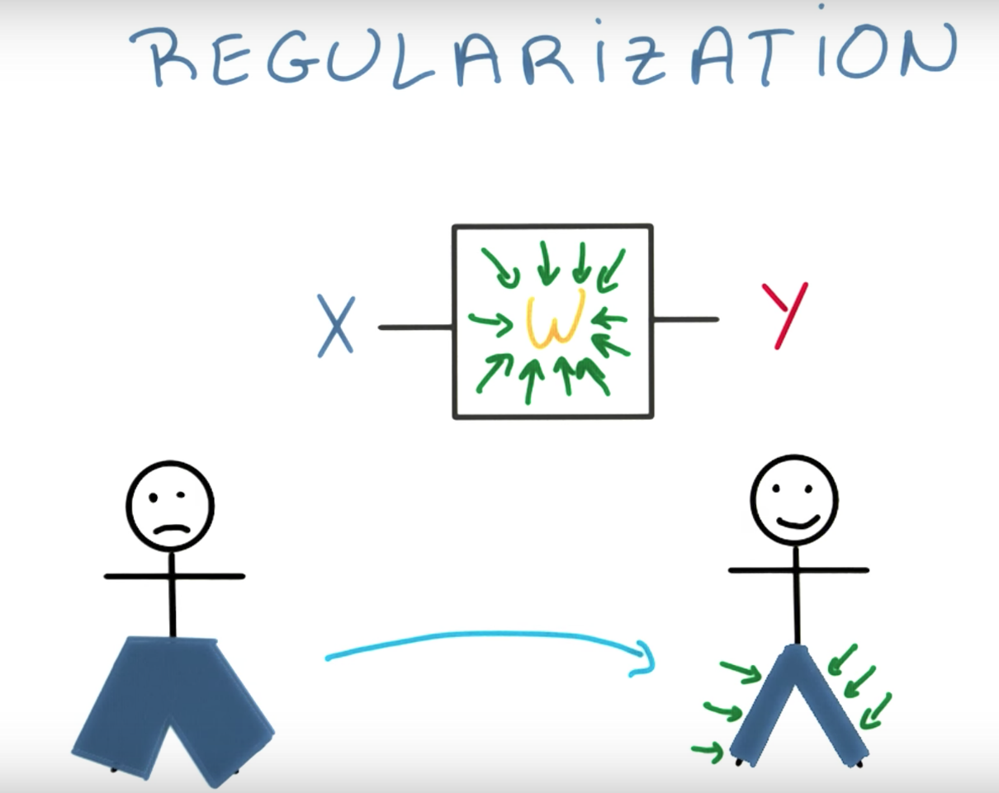

**Figure-6b:** Stretch Pant analogy of Deep Learning

B08086_01_07.png

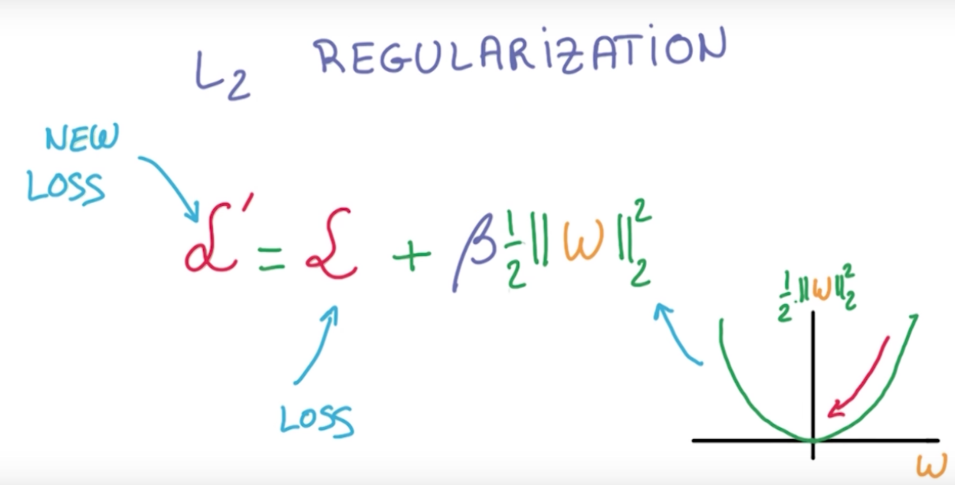

**Figure-6c:** L2 Regularization

B08086_01_08.png

## Shared weights and Pooling

Let say an image has a cat in it and it doesn't really matter where the cat is in the image, it's still an image with a cat. If the network has to learn about cats in the left corner and about cats in the right corner, independently, that's a lot of work that it has to do. But objects and images are largely the same whether they're on the left or on the right of the picture. That's what's called translation invariance.

The way of achieving this in the networks is called weight sharing. When network know that two inputs can contain the same kind of information, then it can share the weights and train the weights jointly for those inputs. It is a very important idea. Statistical invariants, are things that don't change on average across time or space, are everywhere. For images, the idea of weight sharing will get us to study convolutional networks. For text and sequences in general, it will lead us to recurrent neural networks.

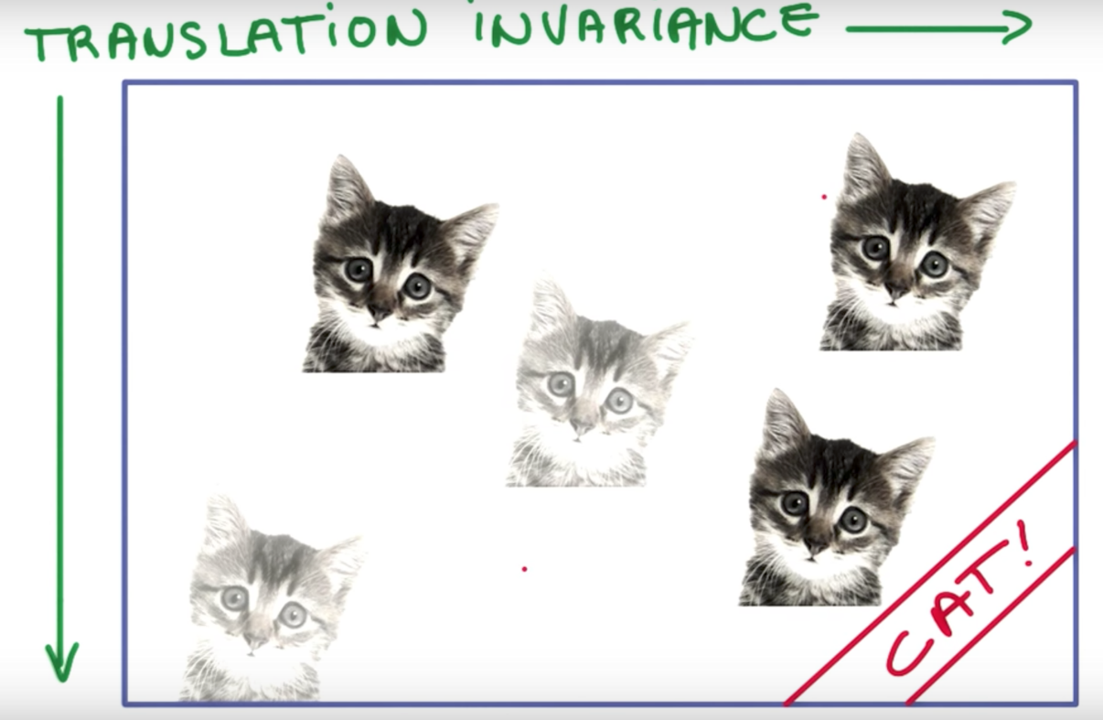

**Figure-7a:** Translation Variance

B08086_01_09.png

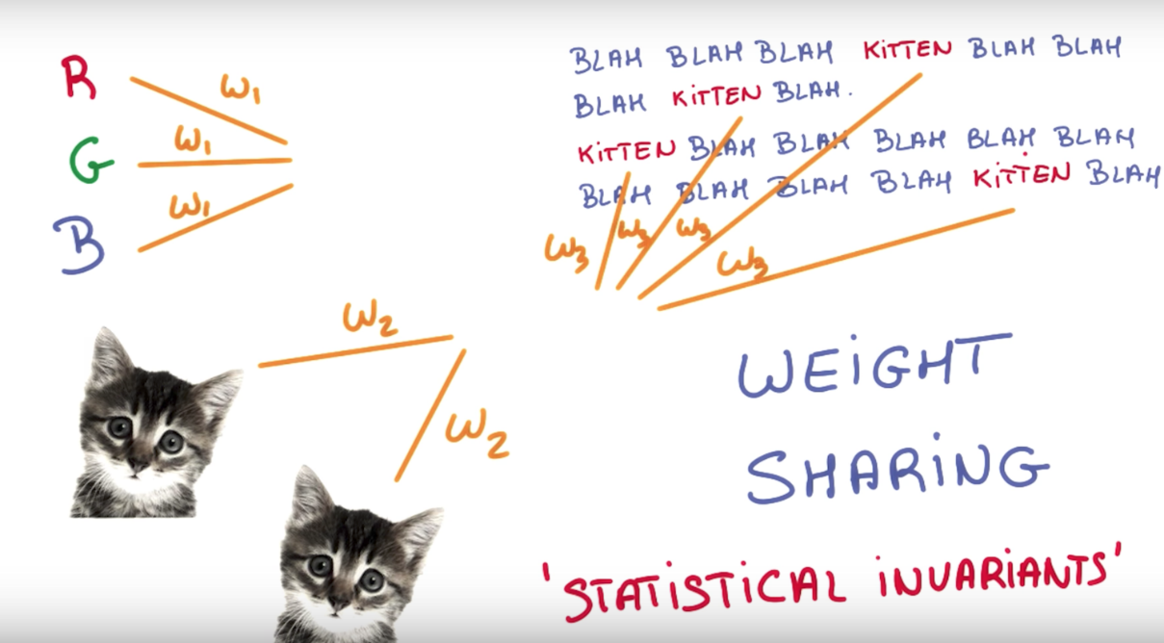

**Figure-7b:** Weight Sharing

B08086_01_10.png

To reduce the spatial extent of the feature maps in the convolutional pyramid, a very small stride could run and took all the convolutions in a neighborhood and combined them somehow. This is known as Pooling.

In max-pooling as shown in Figure-7d, at every point in the future map, looking at a small neighborhood around that point and compute the maximum of all the responses around it. There are some advantages to using max pooling. First, it doesn't add to your number of parameters. So, you don't risk an increasing over fitting. Second, it simply often yields more accurate models. However, since the convolutions that run below run at a lower stride, the model then becomes a lot more expensive to compute. Max pooling extracts the most important feature, whereas Average pooling sometimes can’t extract good features because it takes all into count and results an average value which may/may not be important for object detection type tasks.

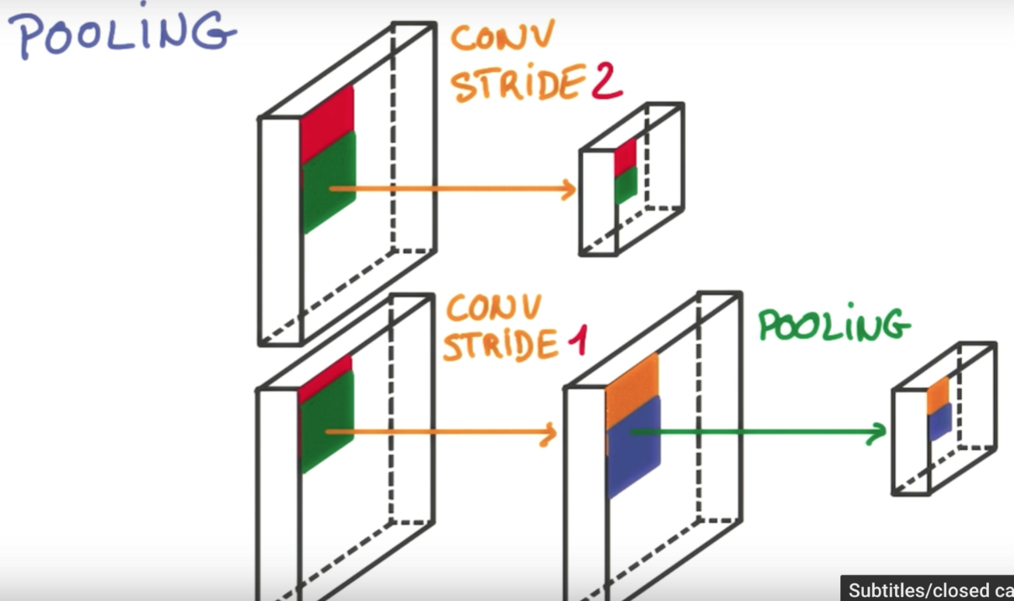

Figure-7c: Pooling

B08086_01_11.png

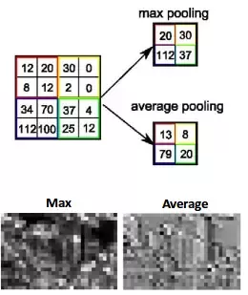

**Figure-7d:** Max and Average Pooling

B08086_01_12.png

## Local Receptive field

A simple way to encode the local structure is to connect a submatrix of adjacent input neurons into one single hidden neuron belonging to the next layer. That single hidden neuron represents one local receptive field. Let consider CIFAR-10 images that has input feature of size [32x32x3]. If the receptive field (or the filter size) is 4x4, then each neuron in the Convolution Layer will have weights to a [4x4x3] region in the input feature, for a total of 4*4*3 = 48 weights (and +1 bias parameter). The extent of the connectivity along the depth axis must be 3, since this is the depth (or number of channel: RGB) of the input feature.

## Convolutional Network- ConvNet

Convnets are neural networks that share their parameters/weights across space. An image can be represented as a flat pancake that has width, height and depth or number of channel (for RGB- having red, green, and blue channel the depth is 3, whereas for grayscale the depth is 1). Now let’s slide a tiny neural network having K outputs across the image without changing the weights.

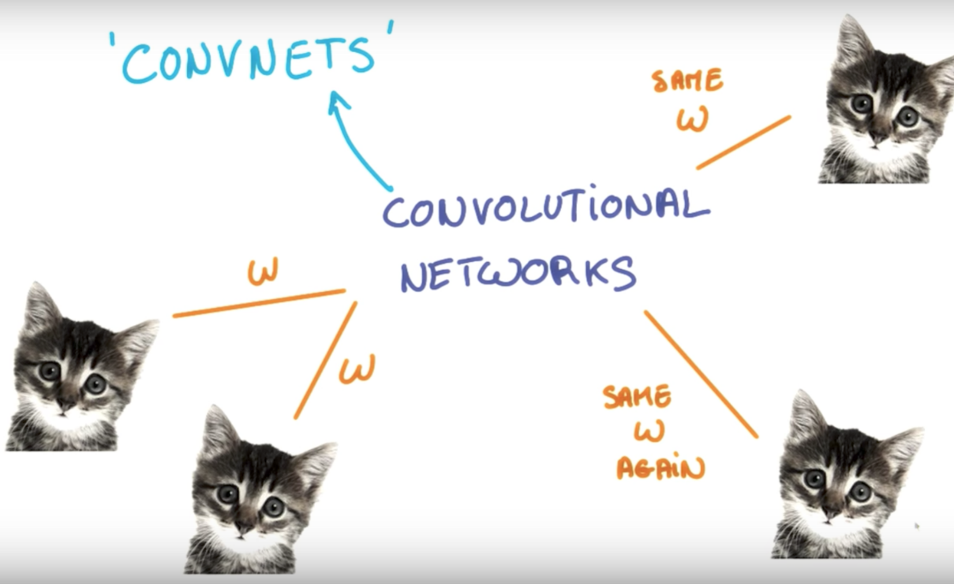

**Figure-8a:** Weight Sharing across space

B08086_01_13.png

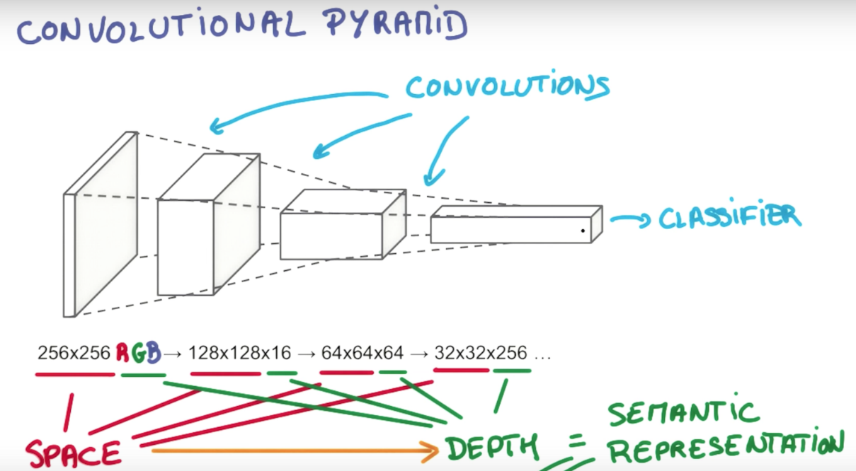

B08086_01_14a.png

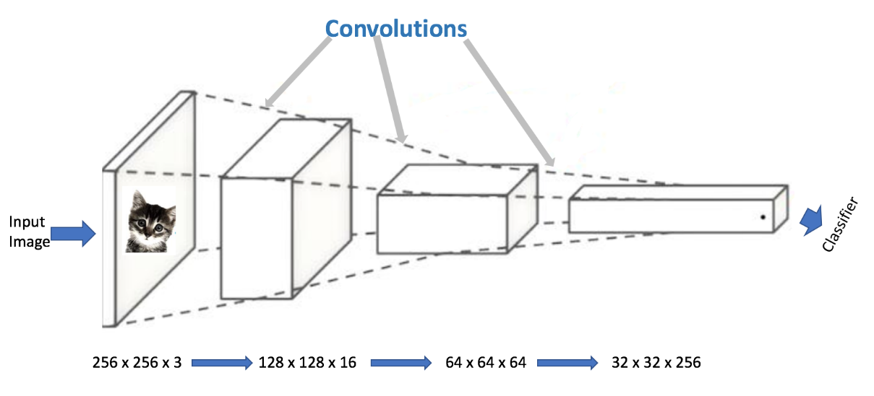

**Figure-8b:** Convolutional pyramid with layers of convolution

B08086_01_14b.png

On the output, a different image will be drawn having different width, different height and different depth (from just R,G,B color channels to K number of channels).This operation is known as convolution.

A Convnet is going to basically be a deep network having layers of convolutions stack together to form a pyramid like structure. As you can see from the picture above that the network takes an image as input of dimension (width x height x depth) and then apply convolutions progressively over it to reduce spatial dimension while increasing the depth which is roughly equivalent to its semantic complexity. Let’s understand some of the common terminology in convent.

Each layer or depth in the image stack is called a feature map and patches or kernel are used for mapping three feature maps to K feature maps. A stride is the number of pixels that is shifted each time you move your filter. Depending on the type of padding a stride of 1 makes the output roughly the same size as the input. A stride of 2 makes it's about half the size. In case of valid padding, sliding filter don’t cross the edge of the image, whereas in same-padding it goes off the edge and padded with zeros to make the output map size exactly the same size as the input map.

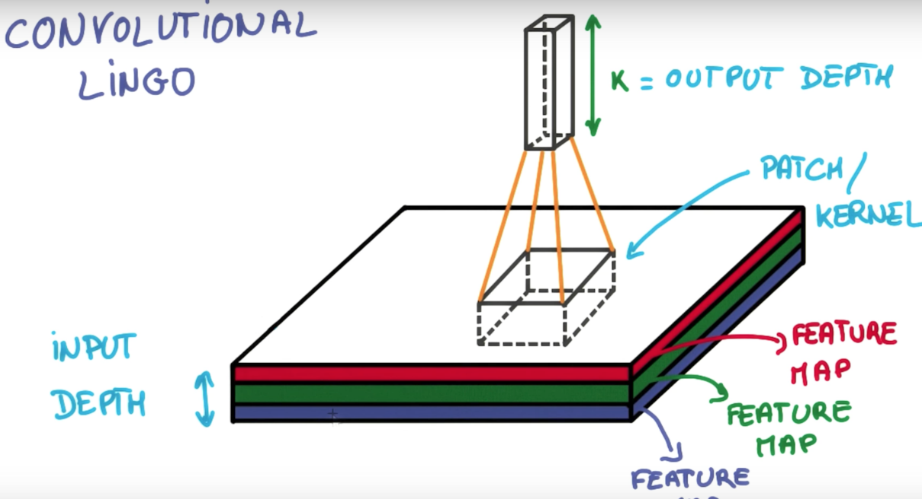

B08086_01_15.png

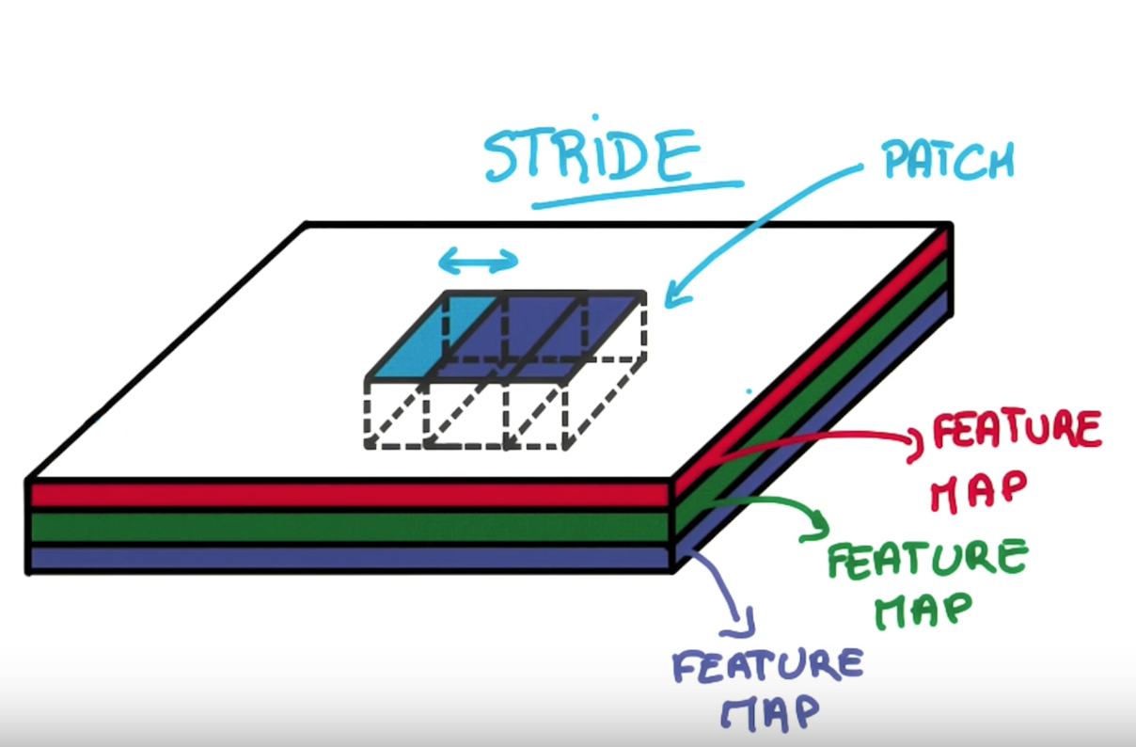

**Figure-8c:** Different terminology related to Convolutional Network

B08086_01_16.png

# Deconvolution or Transpose Convolution

In the case of computer vision application where resolution of final output is required to be larger than input, deconvolution/transposed convolution is the de-facto standard. This layer is used in very popular in applications like Generative Adversarial Networks (GAN), image super-resolution, surface depth estimation from image, optical flow estimation etc.

CNN in general performs down-sampling, i.e. they produce output of lower resolution than the input. Whereas in deconvolution layer up-samples the image to get the same resolution as the input image. Note since a naive up-sampling inadvertently loses details, a better option is to have a trainable up-sampling convolutional layer, whose parameters will change during training.

Tensorflow method: tf.nn.conv2d_transpose(value, filter, output_shape, strides, padding, name)

## Recurrent Neural Network and LSTM

The key idea behind recurrent neural networks (RNN) is to share parameters over time. Imagine that you have a sequence of events, at each point in time you want to make a decision about what's happened so far in this sequence. If the sequence is reasonably stationary, you can use the same classifier at each point in time. That simplifies things a lot already. But since this is a sequence, you also want to take into account the past. Everything that happened before that point.

RNN is going to have a single model responsible for summarizing the past and providing that information to your classifier. It basically ends up with a network having a relatively simple repeating pattern with part of the classifier connecting to the input at each time step and another part called the recurrent connection connecting you to the past at each step as shown in figure below.

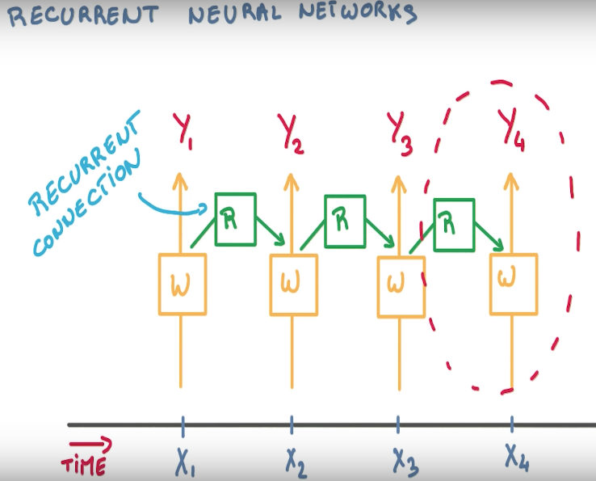

**Figure-9a:** Recurrent Neural Network

B08086_01_18.png

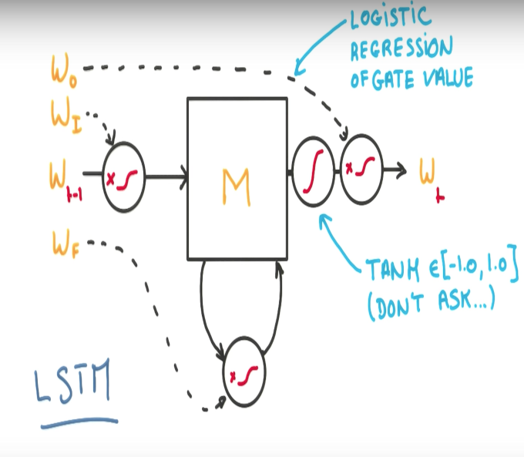

Figure-9b: Long Short-Term Memory (LSTM)

B08086_01_19.png

**LSTM** stands for **long short-term memory**. Now, conceptually, a recurrent neural network consists of a repetition of simple little units like this, which take as an input the past, a new input, and produces a new prediction and connects to the future. Now, what's in the middle of that is typically a simple set of layers with some weights and linearities.

In LSTM as shown in Figure-9b, the gating values for each gate get controlled by a tiny logistic regression on the input parameters. Each of them has its own set of shared parameters. And there's an additional hyperbolic tension sprinkled to keep the outputs between -1 and 1. Also it's differentiable all the way, which means it can optimize the parameters very easily. All these little gates help the model keep its memory longer when it needs to, and ignore things when it should.

## Deep Neural Network

The central idea of deep learning is to add more layers and make your model deeper. There are lots of good reasons to do that. One is parameter efficiency. You can typically get much more performance with fewer parameters by going deeper rather than wider.

Another one is that a lot of natural phenomena that you might be interested in, tend to have a hierarchical structure which deep models naturally capture. If you poke at a model for images, for example, and visualize what the model learns, you'll often find very simple things at the lowest layers, like lines or edges.

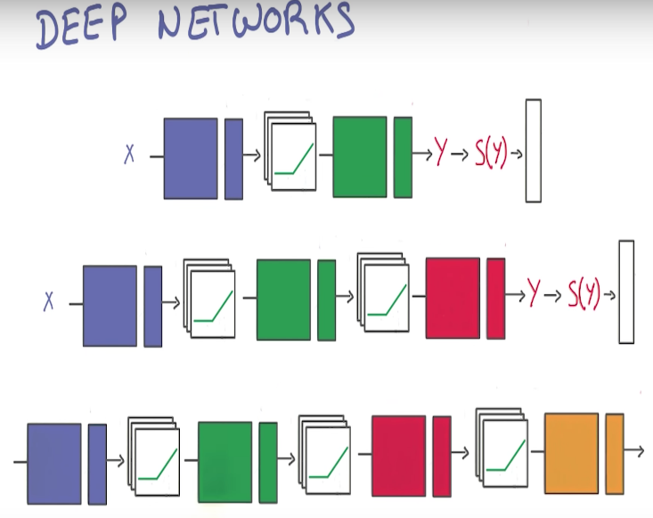

**Figure-10a:** Deep Neural Network

B08086_01_20.png

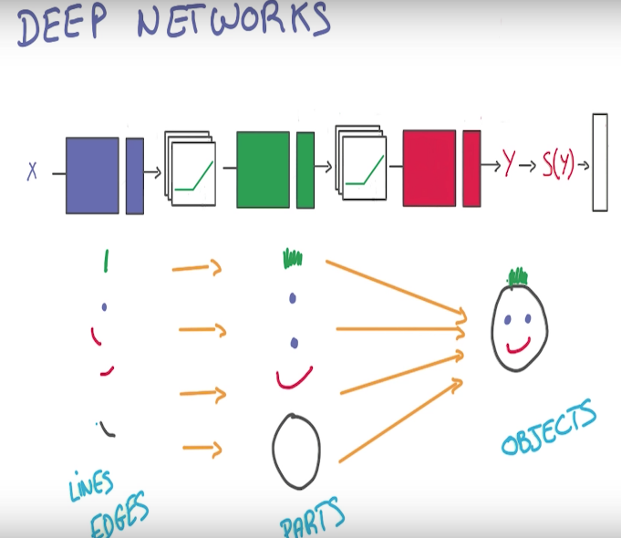

Figure-10b: Network layers capturing hierarchical structure of image

B08086_01_21.png

A very typical architecture for a ConvNet is a few layers alternating convolutions and max pooling, followed by a few fully connected layers at the top. The first famous model to use this architecture was LENET-5 designed by Yann Lecun to the character recognition back in 1998.

Modern convolutional networks such as ALEXNET, which famously won the competitive ImageNet object recognition challenge in 2012, used a very similar architecture with a few wrinkles. Another notable form of pooling is average pooling. Instead of taking the max, just take an average over the window of pixels around a specific location.

## Discriminative vs. Generative models

A generative model learns the joint probability distribution p(x,y). A generative model can generate more samples by its own artificially based on the assumption about the distribution of data. For example, in Naive Bayes model, you can learn p(y), the prior class probabilities from the data and you can also learn p(x|y) from the data using say maximum likelihood. Once you have p(y) and p(x|y), p(x, y) is not difficult to find out.

Instead of modeling p(x, y), a discriminative model learns the conditional probability distribution p(y|x) - which could be interpreted as “probability of y given x". A discriminative classifier learns by observing data. It makes fewer assumptions on the distributions but depends heavily on the quality of the data. For example, in Logistic regression all we have to do is to learn weights and bias that would minimize the squared loss.

Also, the discriminative models generally outperform generative models in classification tasks, but the generative model shines over generative model in creativity/generation task.

## Automate human tasks with Deep Neural Network

In the last few years, there has been an explosion of Deep Neural Networks that are capable of performing image classification, voice recognition and understanding natural language with a good accuracy.

The current state of the art algorithms within the field of deep neural network are able to learn highly complex models of the patterns inherent in a set of data. While the capabilities are impressive, But, human beings are capable of doing much more than just image recognition or understanding what people are talking around and automating those task through machine seems far-fetched.

Let us see some use-cases where we need human creativity (at least as of now):

* Training an artificial author which can write an article and explain data science concepts to a community in a very simplistic manner by learning from past articles from Wikipedia.

Creating an artificial painter which can paint like any famous artist by learning from his / her past collections.

Do you believe that machines are capable of accomplishing these tasks? To your surprise the answer is “YES”.

Of course, these are difficult tasks to automate, but Generative Adversarial Networks (GANs) have started making some of these tasks possible.

Yann LeCun, a prominent figure in Deep Learning Domain (Director of Facebook AI) said that

“Generative Adversarial Network(GANs), and the variations that are now being proposed is the most interesting idea in the last 10 years in Machine Learning”

If you feel intimidated by the name GAN – don’t worry! You will master this technique and apply it to real world problem yourself by the end of this book ☺

## Purpose of Generative Adversarial Network

Some generative models are able to generate samples from the model distribution. Generative adversarial networks are an example of generative models. GAN focus primarily on generating samples from distribution.

You might be wondering why generative models are worth studying, especially generative models that are only capable of generating data rather than providing an estimate of the density function.

Some of the reasons to study generative models are as follows:

* Sampling (or generation) is straightforward.
* Training doesn't involve Maximum Likelihood estimation.
* Robust to Overfitting since Generator never sees the training data.

GANs are good at capturing the modes of the distribution.

## Analogy from real world

Let’s consider the real-world relationship between a money counterfeiting criminal and a police. Let’s enumerate the objective of the criminal and the police in terms of money:

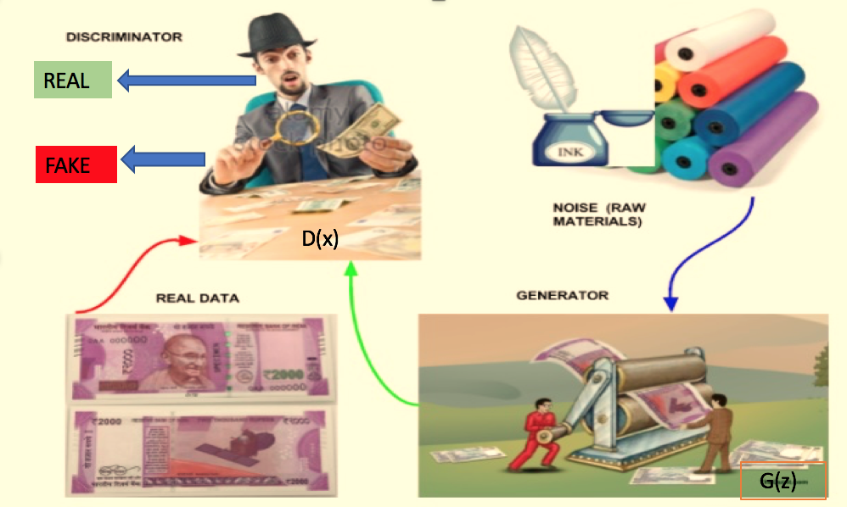

**Figure-11a:** GAN real world analogy

B08086_01_22.png

* To become a successful money counterfeiter, the criminal wants to fool the police, so that the police can’t tell the difference between counterfeited/fake money and real money.

As a paragon of justice, the police want to detect fake money as nicely as possible.

This can be modeled as a minimax game in Game Theory. This phenomenon is called Adversarial Process. Generative Adversarial Network (GAN) introduced by Ian Goodfellow in 2014 at arXiv: 1406.2661 , is a special case of Adversarial Process where two neural network competes against each other. The first network generates data, and the second network tries to find the difference between the real data and the fake data generated by the first network. The second network will output a scalar [0, 1] which represents a probability of real data.

## Building blocks of GAN

 In GAN, the first network is called Generator often represented as G (Z) and the second network called Discriminator often represented as D (X).

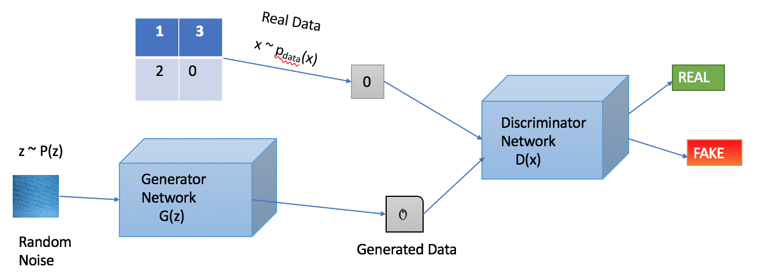

Figure-11b: Generative Adversarial Network

B08086_01_23.png

At the equilibrium point, which is the optimal point in minimax game, the first network will model the real data, and the second network will output probability of 0.5 as the output of the first network = real data.



B08086_01_24.png

Sometimes the two network eventually reach an equilibrium, but this is not always guaranteed and the two network can continue learning for a long time. An example of learning with both generator and discriminator loss is shown below:

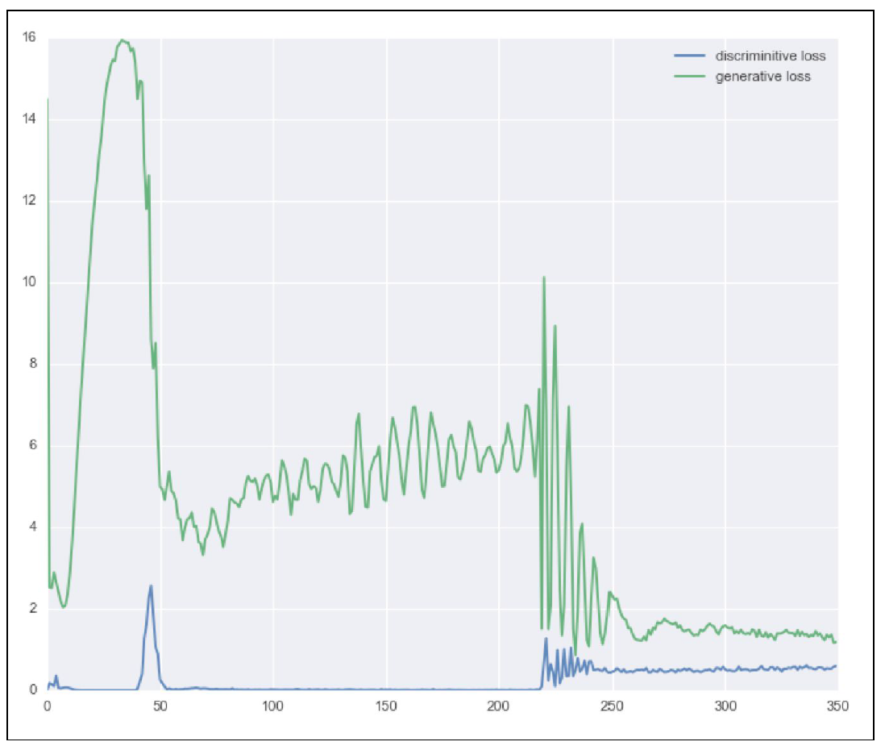

**Figure-11c:** Loss of two networks, generator and discriminator

B08086_01_25.png

### Generator

The Generator Network takes as input random noise and tries to generate a sample of data. In the above image, we can see that generator G(z) takes an input z from probability distribution p(z) and generates a data which is then fed into a discriminator network D(x).

### Discriminator

The Discriminator Network take input either from the real data or from the generator’s generated data and try to predict whether the input is real or generated. It takes an input x from real data distribution Pdata(x) and then solves a binary classification problem giving output in the scalar range 0 to 1.

GANs are gaining lot of popularity because of their ability to tackle the important challenge of unsupervised learning, since the amount of available un-labelled data is much larger than the amount of labelled data. Another reason for their popularity is that GANs are able to generate the most realistic images among generative models. Although this is subjective, but it is an opinion shared by most practitioners.

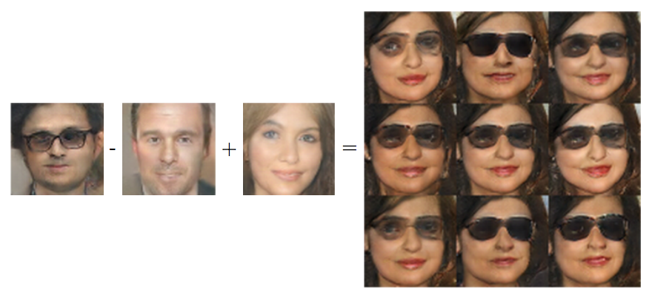

Figure-11d: Vector arithmetic in GANs

B08086_01_26.png

Beside this, GAN is often very expressive: it can perform arithmetic operations in the latent space, that is the space of the z vectors, translate into corresponding operations in feature space. As shown in Figure-11d that if you take the representation of a “man with glass” in latent space, subtract the “neutral man” vector and add back the “neutral woman” vector, you end up with a picture of a “woman with glasses” in feature space. This is truly amazing.

# Implementation of GAN

As per the definition of GAN, we basically require two networks- be it a sophisticated network like convnet or a simple two-layer neural network. Let’s use a simple two-layer neural network with MNIST dataset using Tensorflow for the implementation purpose. MNIST is a dataset of handwritten digits where each image is gray scale of dimension 28x28 pixel.

# Random noise setting for Generator

Z = tf.placeholder(tf.float32, shape=[None, 100], name='Z')

#Generator parameter settings

G_W1 = tf.Variable(xavier_init([100, 128]), name='G_W1')

G_b1 = tf.Variable(tf.zeros(shape=[128]), name='G_b1')

G_W2 = tf.Variable(xavier_init([128, 784]), name='G_W2')

G_b2 = tf.Variable(tf.zeros(shape=[784]), name='G_b2')

theta_G = [G_W1, G_W2, G_b1, G_b2]

# Generator Network

def generator(z):

G_h1 = tf.nn.relu(tf.matmul(z, G_W1) + G_b1)

G_log_prob = tf.matmul(G_h1, G_W2) + G_b2

G_prob = tf.nn.sigmoid(G_log_prob)

return G_prob

The generator(z) takes as input a 100-dimensional vector from a random distribution (in this case we are using uniform distribution) and returns 786-dimensional vector, which is MNIST image (28x28). z here is the prior for the G(Z). In this way, it learns a mapping between the prior space to Pdata (real data distribution).

#Input Image MNIST setting for Discriminator [28x28=784]

X = tf.placeholder(tf.float32, shape=[None, 784], name='X')

#Discriminator parameter settings

D_W1 = tf.Variable(xavier_init([784, 128]), name='D_W1')

D_b1 = tf.Variable(tf.zeros(shape=[128]), name='D_b1')

D_W2 = tf.Variable(xavier_init([128, 1]), name='D_W2')

D_b2 = tf.Variable(tf.zeros(shape=[1]), name='D_b2')

theta_D = [D_W1, D_W2, D_b1, D_b2]

# Discriminator Network

def discriminator(x):

D_h1 = tf.nn.relu(tf.matmul(x, D_W1) + D_b1)

D_logit = tf.matmul(D_h1, D_W2) + D_b2

D_prob = tf.nn.sigmoid(D_logit)

return D_prob, D_logit

Whereas the discriminator(x) takes MNIST image(s) as input and return a scalar that represents a probability of real image. Now, let’s us discuss algorithm for training GAN. Here’s the pseudo code for training algorithm from the paper- arXiv: 1406.2661, 2014:

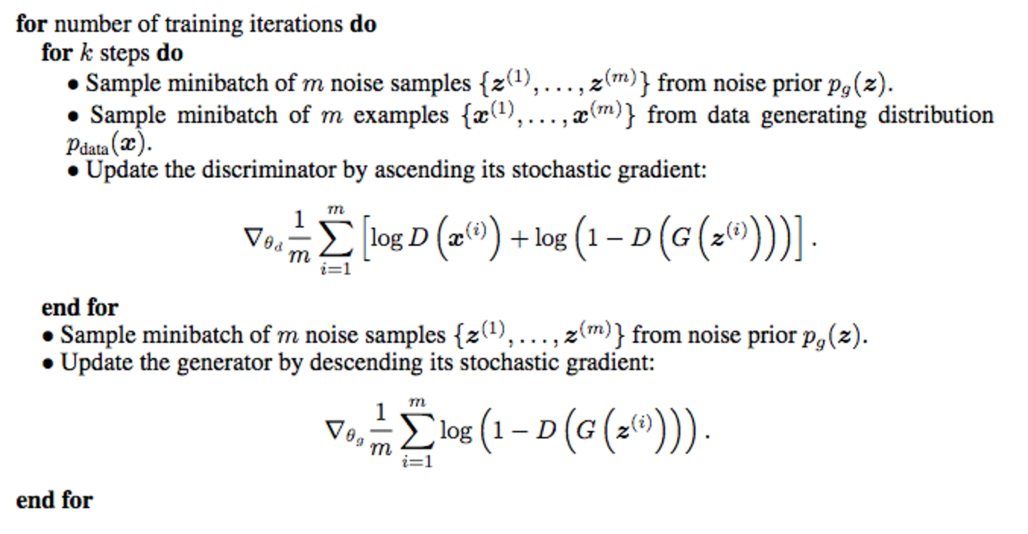

Figure-11e: GAN training algorithm pseudo-code

B08086_01_27.png

G_sample = generator(Z)

D_real, D_logit_real = discriminator(X)

D_fake, D_logit_fake = discriminator(G_sample)

# Loss functions according the GAN original paper

D_loss = -tf.reduce_mean(tf.log(D_real) + tf.log(1. - D_fake))

G_loss = -tf.reduce_mean(tf.log(D_fake))

Tensorflow optimizer can only do minimization, so in order to maximize the loss function, we are using negative sign for the loss as seen above. Also, as per the paper’s pseudo algorithm, it’s better to maximize tf.reduce_mean(tf.log(D_fake)) instead of minimizing tf.reduce_mean(1 - tf.log(D_fake).Then we train the networks one by one with those loss functions above.

# Only update D(X)'s parameters, so var_list = theta_D

D_solver = tf.train.AdamOptimizer().minimize(D_loss, var_list=theta_D)

# Only update G(X)'s parameters, so var_list = theta_G

G_solver = tf.train.AdamOptimizer().minimize(G_loss, var_list=theta_G)

def sample_Z(m, n):

'''Uniform prior for G(Z)'''

return np.random.uniform(-1., 1., size=[m, n])

for it in range(1000000):

X_mb, _ = mnist.train.next_batch(mb_size)

_, D_loss_curr = sess.run([D_solver, D_loss], feed_dict={X: X_mb, Z: sample_Z(mb_size, Z_dim)})

_, G_loss_curr = sess.run([G_solver, G_loss], feed_dict={Z: sample_Z(mb_size, Z_dim)})

After that we start with random noise and as the training continues, G(Z) starts moving toward pdata. This is proved by the more and more similar samples generated by G(Z) compared to original MNIST images.

Some of the output generated after 60000 iteration is shown below:

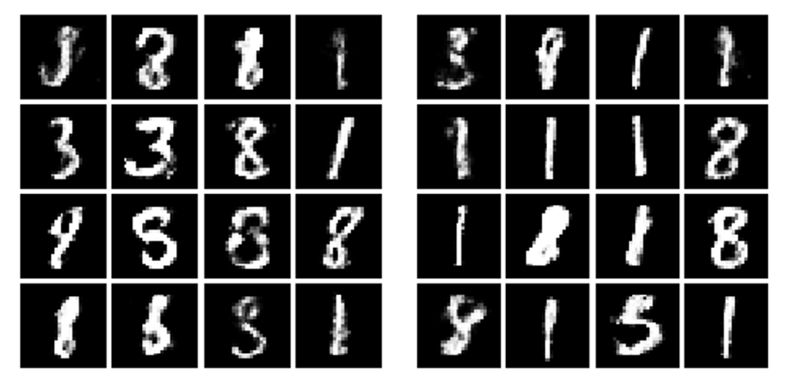

Figure-11f: GAN implementation of generated output image

B08086_01_28.png

## Application of GAN

Generative Adversarial Network is gaining lots of excitement in wide variety of fields. Some of the exciting application of GAN in recent years are listed below:

* Performing perform image completion, editing and painting through Conditional GAN. Details will be covered in Chapter 2.
* Producing audio and recognizing speech from sentence using WaveNet neural model. Details will be covered in Chapter 2.
* Translating one image to another (like Horse to Zebra) with CycleGAN. Details will be covered in Chapter 2.
* Automatic synthesis of realistic images from textual sentence using StackGAN. Details will be covered in Chapter 3.
* Transferring style from one domain to another domain using Discovery GAN (DiscoGAN). Details will be covered in Chapter 3
* Enhancing image quality and generating high resolution image with pre-trained model using SRGAN. Details will be covered in Chapter 4.
* Generating Realistic Image from Attribute: Let say a burglar come to your apartment but you don’t have any picture of him/her. Now the system at police station could generate realistic image of the thief based on the description provided by you and search from database. For more information refer- arXiv: 1605.05396, 2016

Predicting the next frame in a video or dynamic video generation: (http://carlvondrick.com/tinyvideo/)

## Image generation with DCGAN using Keras

The deep convolutional generative adversarial networks (DCGAN) are introduced in the paper: Unsupervised Representation Learning with Deep Convolutional Generative Adversarial Networks, by A. Radford, L. Metz, and S. Chintala, arXiv:1511.06434, 2015.

The generator uses a 100-dimensional, uniform distribution space, Z which is then projected into a smaller space by a series of convolution operations. An example is shown in the following figure:

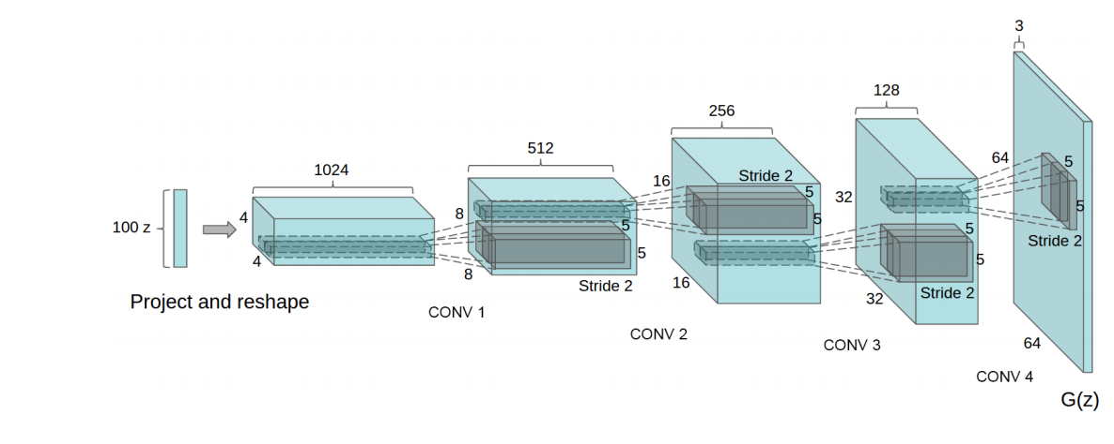

Figure-12: DCGAN architecture of the generator

Source- arXiv, 1511.06434,2015

B08086_01_44.png

DCGAN stabilizes the networks with the following architectural constraints:

* Replace any pooling layers with strided convolutions in discriminator and fractional-strided convolutions in generator.
* Use batchnorm in both the generator and the discriminator
* Remove fully connected hidden layers for deeper architectures and simply use average pooling at the end.
* Use ReLU activation in generator for all layers except for the output, which uses Tanh.

Use LeakyReLU activation in the discriminator for all layers.

A DCGAN generator can be described by the following code implemented in Keras, available at: <https://github.com/jacobgil/keras-dcgan> :

Start the training/generation process with the following command:

python dcgan.py --mode train --batch_size <batch_size>

python dcgan.py --mode generate --batch_size <batch_size> --nice

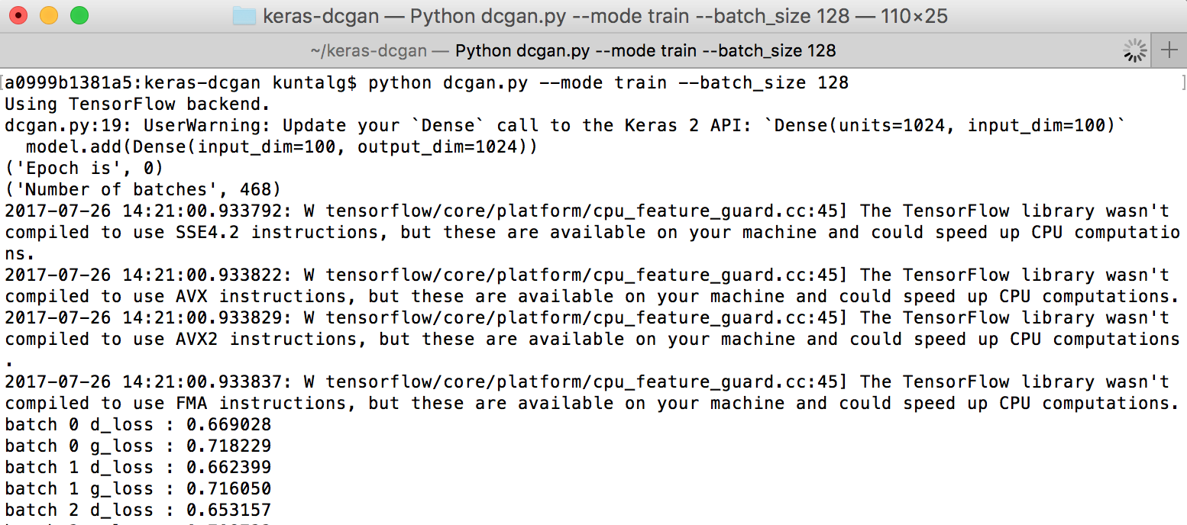

B08086_01_29.png

Note that the Number of batches printed above is calculated based on input image shape/BATCH_SIZE(provided).

Now let’s jump into the code. The generator can be described with the following:

def generator_model():

model = Sequential()

model.add(Dense(input_dim=100, output_dim=1024))

model.add(Activation('tanh'))

model.add(Dense(128*7*7))

model.add(BatchNormalization())

model.add(Activation('tanh'))

model.add(Reshape((7, 7, 128), input_shape=(128*7*7,)))

model.add(UpSampling2D(size=(2, 2)))

model.add(Conv2D(64, (5, 5), padding='same'))

model.add(Activation('tanh'))

model.add(UpSampling2D(size=(2, 2)))

model.add(Conv2D(1, (5, 5), padding='same'))

model.add(Activation('tanh'))

return model

The first dense layer of the generator takes as input a vector of 100 dimensions and it produces output of 1,024 dimensions with the activation function tanh.

The next dense layer in the network produces data of 128 x 7 x 7 in the output using batch normalization (refer to Batch Normalization Accelerating Deep Network Training by Reducing Internal Covariate Shift, by S. Ioffe and C.Szegedy, arXiv: 1502.03167, 2014), a technique that often help to stabilize learning by normalizing the input with zero mean and unit variance. Batch normalization has been empirically proven to speed-up the training in many situations, reduce the problems of poor initialization, and in general produces more accurate results. There is also a Reshape() module that produces data of 128 x 7x 7 (128 channels, 7 width, and 7 height), dim_ordering to tf , and a UpSampling() module that produces a repetition of each one into a 2 x 2 square. After that, we have a convolutional layer that produces 64 filters on 5 x 5 convolutional kernels/patches with tanh activation having same padding followed by a new UpSampling() and a final convolution with one filter, and on 5 x 5 convolutional kernels with the activation as tanh. Note there are no pooling operations in the ConvNet.

The discriminator can be described with the following code:

def discriminator_model():

model = Sequential()

model.add(Conv2D(64, (5, 5), padding='same',input_shape=(28, 28, 1)))

model.add(Activation('tanh'))

model.add(MaxPooling2D(pool_size=(2, 2)))

model.add(Conv2D(128, (5, 5)))

model.add(Activation('tanh'))

model.add(MaxPooling2D(pool_size=(2, 2)))

model.add(Flatten())

model.add(Dense(1024))

model.add(Activation('tanh'))

model.add(Dense(1))

model.add(Activation('sigmoid'))

return model

The discriminator takes a standard MNIST image with the shape (1, 28, 28) and applies a

convolution with 64 filters of size 5 x 5 with tanh as the activation function. It is then followed by a max-pooling operation of size 2 x 2 and by a further convolution max-pooling operation. The last two stages are dense, with the final one being the prediction for forgery, which consists of only single neuron with a sigmoid activation function. For a given number of epochs, the generator and discriminator are trained by using binary_crossentropy as loss function. At each epoch, the generator makes prediction of a number (for example, it creates forged MNIST images) and the discriminator tries to learn after mixing the prediction with real MNIST images. After few epochs, the generator automatically learns to forge this set of handwritten numbers.

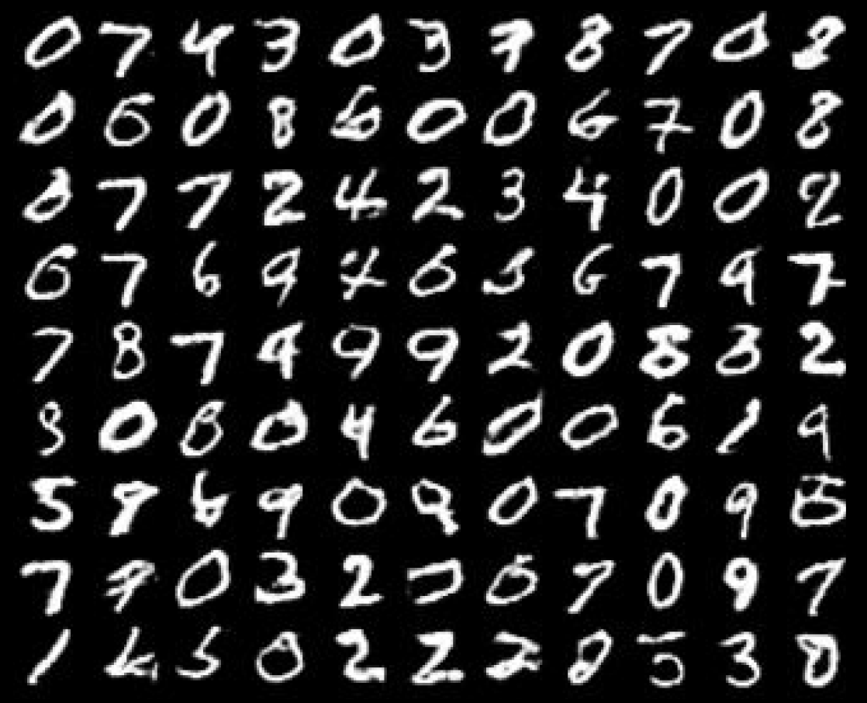

Figure-12: Deep Convolutional GAN generated handwritten digit output

B08086_01_30.png

Note that training GANs could be very difficult because it is necessary to find the equilibrium between two players and hence some of the valuable techniques and tips used by the practitioners are given in the final section of this chapters.

## Implementing SSGAN using Tensorflow

The basic intuition of Semi-Supervised Learning Generative Adversarial Network (SSGAN) is to exploit the samples generated by generators to enhance the performance of image classification tasks of the discriminator by improving generalization. The key idea is to train one of the network as both image classifier and discriminator (to identify generated images from real images).

For a dataset having n classes, the dual trained (discriminator/classifier) network will takes an image as input and classify the real images into the first n classes and generated images into the n+1-th class, as shown in the figure below.

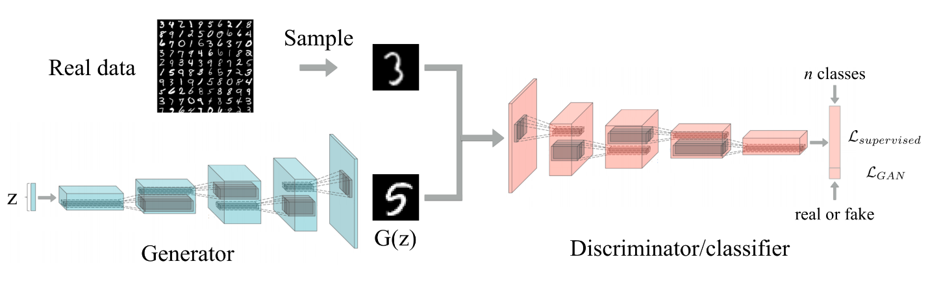

Source: https://github.com/gitlimlab/SSGAN-Tensorflow/blob/master/figure/ssgan.png

B08086_01_31.png

This multi-tasking learning framework consist of two losses- first the supervised loss:



B08086_01_32.png

and second the GAN loss of a discriminator:



B08086_01_33.png

During the training phase, both these losses are jointly minimized.

### Setting up the environment

1. Clone the git repo: <https://github.com/gitlimlab/SSGAN-Tensorflow>

\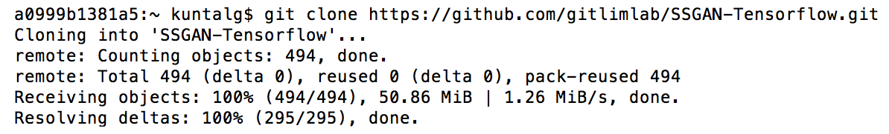

B08086_01_34.png

1. Change directory:

cd SSGAN-Tensorflow/

1. Downloading CIFAR-10 dataset:

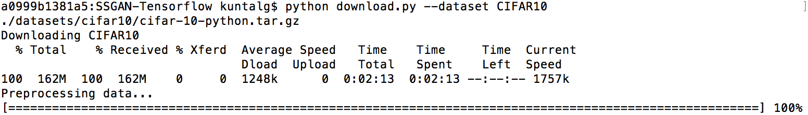

B08086_01_35.png

1. Training the model:

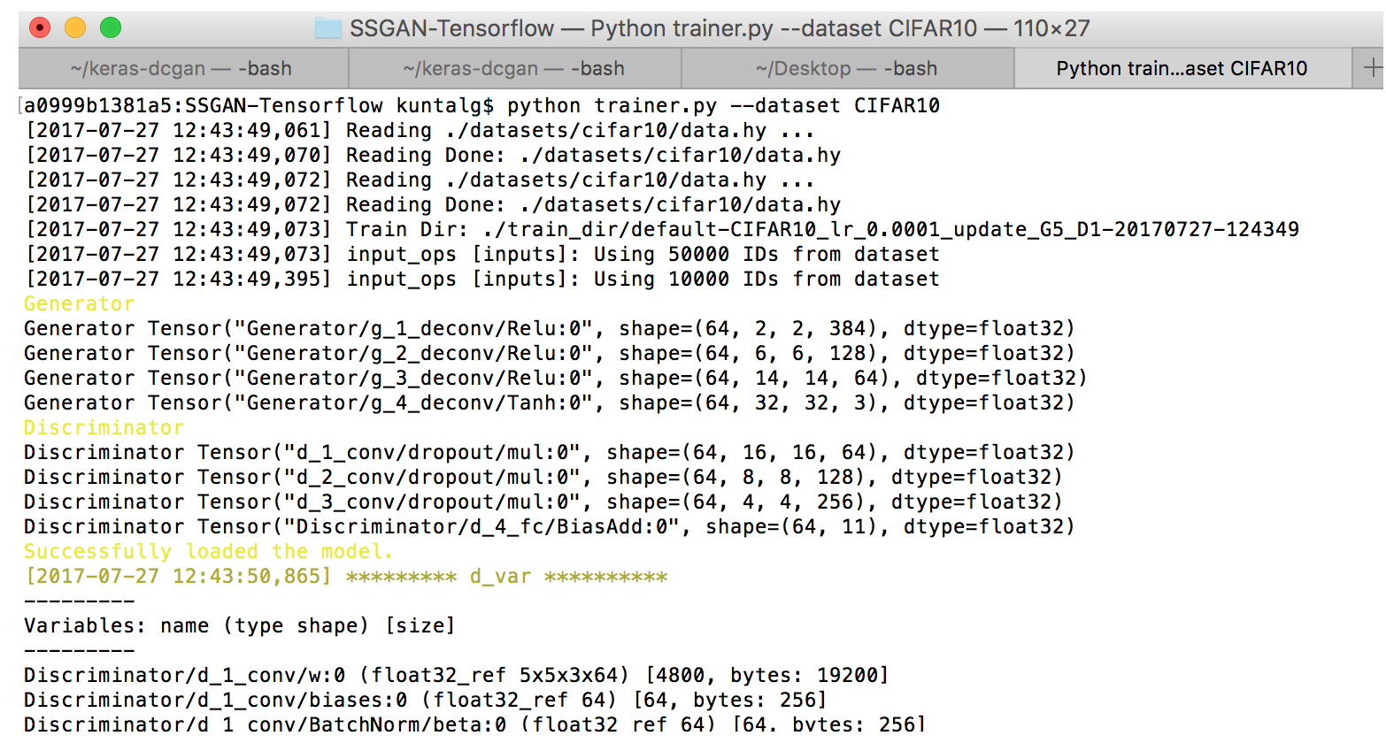

B08086_01_36.png

Testing or Evaluating the model

python evaler.py --dataset CIFAR10 --checkpoint ckpt_dir

Now let’s dive into the code. The generator takes random noise from the uniform distribution.

z = tf.random_uniform([self.batch_size, n_z], minval=-1, maxval=1, dtype=tf.float32)

Then the generator model flattens the input noise to 1 dimensional vector using reshape method. It then applies 3 layers of deconvolution on the input noise having relu activation and then apply one more deconvolution with tanh activation to generate the output image of dimension [h= height, w=width,c], where c is the number of channels (grayscale images: 1, color images: 3).

# Generator model function

def G(z, scope='Generator'):

with tf.variable_scope(scope) as scope:

print ('\033[93m'+scope.name+'\033[0m')

z = tf.reshape(z, [self.batch_size, 1, 1, -1])

g_1 = deconv2d(z, deconv_info[0], is_train, name='g_1_deconv')

print (scope.name, g_1)

g_2 = deconv2d(g_1, deconv_info[1], is_train, name='g_2_deconv')

print (scope.name, g_2)

g_3 = deconv2d(g_2, deconv_info[2], is_train, name='g_3_deconv')

print (scope.name, g_3)

g_4 = deconv2d(g_3, deconv_info[3], is_train, name='g_4_deconv', activation_fn='tanh')

print (scope.name, g_4)

output = g_4

assert output.get_shape().as_list() == self.image.get_shape().as_list(), output.get_shape().as_list()

return output

# Deconvolution method

def deconv2d(input, deconv_info, is_train, name="deconv2d", stddev=0.02,activation_fn='relu'):

with tf.variable_scope(name):

output_shape = deconv_info[0]

k = deconv_info[1]

s = deconv_info[2]

deconv = layers.conv2d_transpose(input,

num_outputs=output_shape,

weights_initializer=tf.truncated_normal_initializer(stddev=stddev),

biases_initializer=tf.zeros_initializer(),

kernel_size=[k, k], stride=[s, s], padding='VALID')

if activation_fn == 'relu':

deconv = tf.nn.relu(deconv)

bn = tf.contrib.layers.batch_norm(deconv, center=True, scale=True,

decay=0.9, is_training=is_train, updates_collections=None)

elif activation_fn == 'tanh':

deconv = tf.nn.tanh(deconv)

else:

raise ValueError('Invalid activation function.')

return deconv

The discriminator takes images as input and tries to output into n+1 class label. It applies some layers of convolution having leaky relu with batch normalization, followed by dropout on the input images and finally output the class label using softmax function.

# Discriminator model function

def D(img, scope='Discriminator', reuse=True):

with tf.variable_scope(scope, reuse=reuse) as scope:

if not reuse: print ('\033[93m'+scope.name+'\033[0m')

d_1 = conv2d(img, conv_info[0], is_train, name='d_1_conv')

d_1 = slim.dropout(d_1, keep_prob=0.5, is_training=is_train, scope='d_1_conv/')

if not reuse: print (scope.name, d_1)

d_2 = conv2d(d_1, conv_info[1], is_train, name='d_2_conv')

d_2 = slim.dropout(d_2, keep_prob=0.5, is_training=is_train, scope='d_2_conv/')

if not reuse: print (scope.name, d_2)

d_3 = conv2d(d_2, conv_info[2], is_train, name='d_3_conv')

d_3 = slim.dropout(d_3, keep_prob=0.5, is_training=is_train, scope='d_3_conv/')

if not reuse: print (scope.name, d_3)

d_4 = slim.fully_connected(

tf.reshape(d_3, [self.batch_size, -1]), n+1, scope='d_4_fc', activation_fn=None)

if not reuse: print (scope.name, d_4)

output = d_4

assert output.get_shape().as_list() == [self.batch_size, n+1]

return tf.nn.softmax(output), output

# Convolution method with dropout

def conv2d(input, output_shape, is_train, k_h=5, k_w=5, stddev=0.02, name="conv2d"):

with tf.variable_scope(name):

w = tf.get_variable('w', [k_h, k_w, input.get_shape()[-1], output_shape],

initializer=tf.truncated_normal_initializer(stddev=stddev))

conv = tf.nn.conv2d(input, w, strides=[1, 2, 2, 1], padding='SAME')

biases = tf.get_variable('biases', [output_shape], initializer=tf.constant_initializer(0.0))

conv = lrelu(tf.reshape(tf.nn.bias_add(conv, biases), conv.get_shape()))

bn = tf.contrib.layers.batch_norm(conv, center=True, scale=True,

decay=0.9, is_training=is_train, updates_collections=None)

return bn

# Leaky Relu method

def lrelu(x, leak=0.2, name="lrelu"):

with tf.variable_scope(name):

f1 = 0.5 * (1 + leak)

f2 = 0.5 * (1 - leak)

return f1 * x + f2 * abs(x)

The discriminator network has two loss function, one (s_loss) for supervise classification of real data from cifar-10 images using huber loss (Huber loss is robust to outliers compared to squared error loss) and other (d_loss) loss to classify the generated images by generator as real/fake in scalar form using softmax with cross entropy.

# Discriminator/classifier loss

s_loss = tf.reduce_mean(huber_loss(label, d_real[:, :-1]))

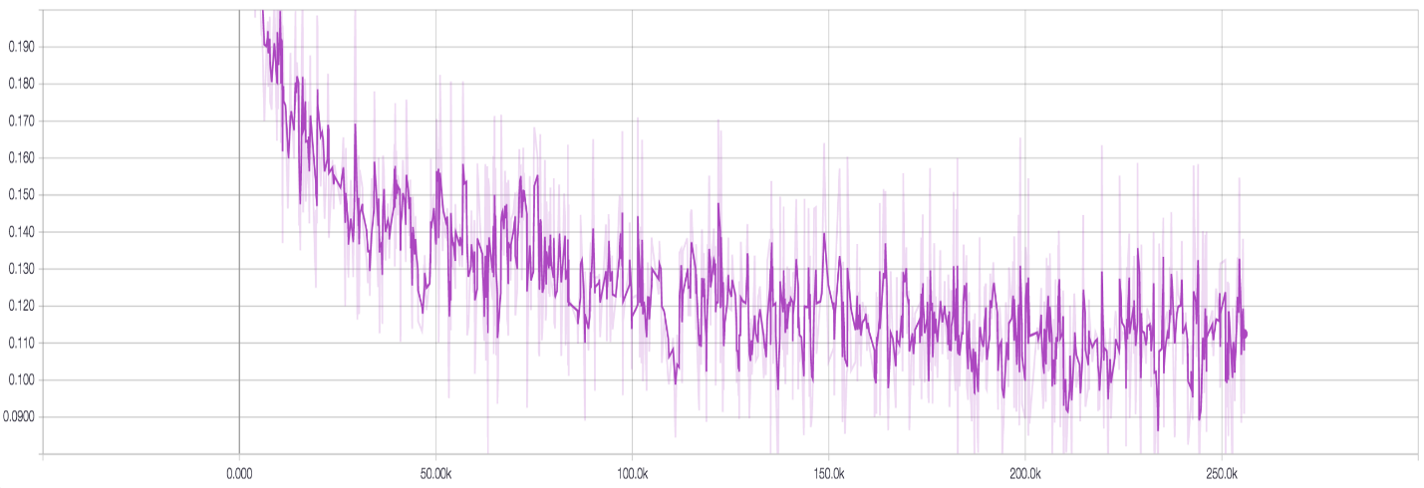

Figure-13a: Supervise loss of discriminator

B08086_01_37.png

d_loss_real = tf.nn.softmax_cross_entropy_with_logits(logits=d_real_logits, labels=real_label)

d_loss_fake = tf.nn.softmax_cross_entropy_with_logits(logits=d_fake_logits, labels=fake_label)

d_loss = tf.reduce_mean(d_loss_real + d_loss_fake)

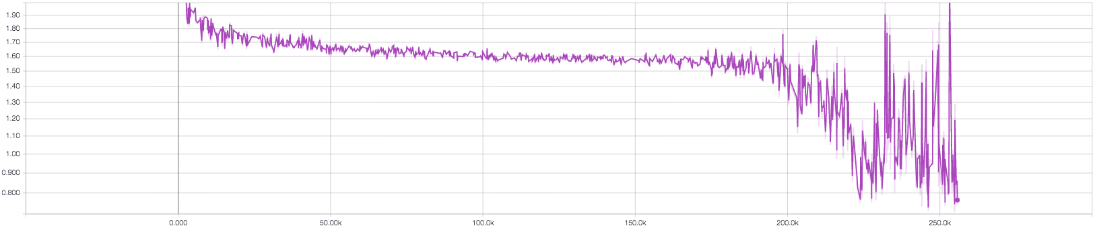

Figure-13b: Total discriminator loss (real + fake loss)

B08086_01_38.png

# Huber loss

def huber_loss(labels, predictions, delta=1.0):

residual = tf.abs(predictions - labels)

condition = tf.less(residual, delta)

small_res = 0.5 * tf.square(residual)

large_res = delta * residual - 0.5 * tf.square(delta)

return tf.where(condition, small_res, large_res)

# Generator loss

g_loss = tf.reduce_mean(tf.log(d_fake[:, -1]))

g_loss += tf.reduce_mean(huber_loss(real_image, fake_image)) * self.recon_weight

Note: Weight annealing is done as an auxiliary loss to help the generator get rid of the initial local minimum.

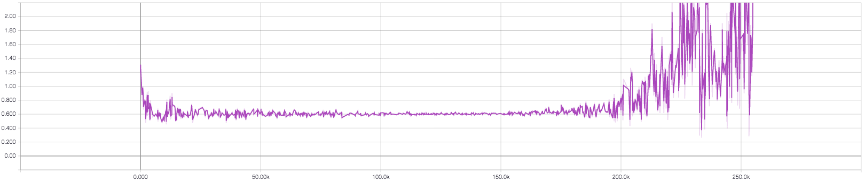

Figure-13c: Generator loss

B08086_01_39.png

The loss function of both the generator and discriminator network is optimized with Adam Optimizer and gradient clipping is applied with it to stabilize the training.

# Optimizer for discriminator

self.d_optimizer = tf.contrib.layers.optimize_loss(

loss=self.model.d_loss,

global_step=self.global_step,

learning_rate=self.learning_rate*0.5,

optimizer=tf.train.AdamOptimizer(beta1=0.5),

clip_gradients=20.0,

name='d_optimize_loss',

variables=d_var

)

# Optimizer for generator

self.g_optimizer = tf.contrib.layers.optimize_loss(

loss=self.model.g_loss,

global_step=self.global_step,

learning_rate=self.learning_rate,

optimizer=tf.train.AdamOptimizer(beta1=0.5),

clip_gradients=20.0,

name='g_optimize_loss',

variables=g_var

)

Finally, both the supervised loss (s_loss) and generative adversarial loss [which is the combination of discriminator loss (d_loss) and generator loss (g_loss)] are trained jointly to minimize the total loss.

for s in xrange(max_steps):

step, accuracy, summary, d_loss, g_loss, s_loss, step_time, prediction_train, gt_train, g_img = \

self.run_single_step(self.batch_train, step=s, is_train=True)

The output of generated samples after 150 epochs as follows:

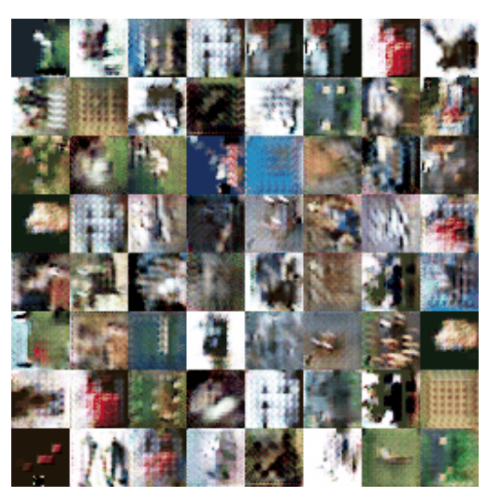

B08086_01_40.png

# Challenges of GAN models

Training a GAN is basically about two networks generator G(z) and discriminator D(z) trying to race against each other and trying to reach an optimum, more specifically a Nash equilibrium. The definition of Nash equilibrium as per Wikipedia:

(in economics and game theory) a stable state of a system involving the interaction of different participants, in which no participant can gain by a unilateral change of strategy if the strategies of the others remain unchanged.

## Setup failure and Bad Initialization

If you think about it, this is exactly what GAN is trying to do, the generator and discriminator reach a state where they cannot improve further given the other is kept unchanged. Now the setup of gradient descent is to take a step in a direction that reduces the loss measure defined on the problem – but we are by no means enforcing the networks to reach Nash equilibrium in GAN which have non-convex objective with continuous high dimensional parameters. The networks try to take successive steps to minimize a non-convex objective and end up in an oscillating process rather than decreasing the underlying true objective.

In most cases, when your discriminator attains a loss very close to zero, then right away you can figure out something is wrong with your model. But the biggest pain-point is figuring out what is wrong ☹😩

Another practical thing done during the training of GAN is to purposefully make one of the network to stall or learn slower, so that the other network can catch up. And in most scenario, it's the generator that lags behind so we usually let the discriminator wait. This might be fine to some extent but remember that for the generator to get better, it requires a good discriminator and vice versa. Ideally the system would want both the networks to learn at a rate where both get better over time. The ideal minimum loss for the discriminator is close to 0.5 - this is where the generated images are indistinguishable from the real images from the perspective of the discriminator.

## Mode Collapse

One of the main failure modes with training a generative adversarial network is called mode collapse or sometimes the helvetica scenario. The basic idea is that the generator can accidentally start to produce several copies of exactly the same image, so the reason is related to the game theory setup we can think of the way that we train generative adversarial networks as first maximizing with respect to the discriminator and then minimizing with respect to the generator. If we fully maximize with respect to the discriminator before we start to minimize with respect to the generator everything works out just fine. But if we go the other way around and we minimize with respect to the generator and then maximize with respect to the discriminator, everything will actually break and the reason is that if we hold the discriminator constant it will describe a single region in space as being the point that is most likely to be real rather than fake and then the generator will choose to map all noise input values to that same most likely to be real point.

## Problem with Counting

GANs can sometime be far-sighted and fails to differentiate the number of particular object that should occur at a location. As we can see below, it gives more number of eyes in the head than originally present.

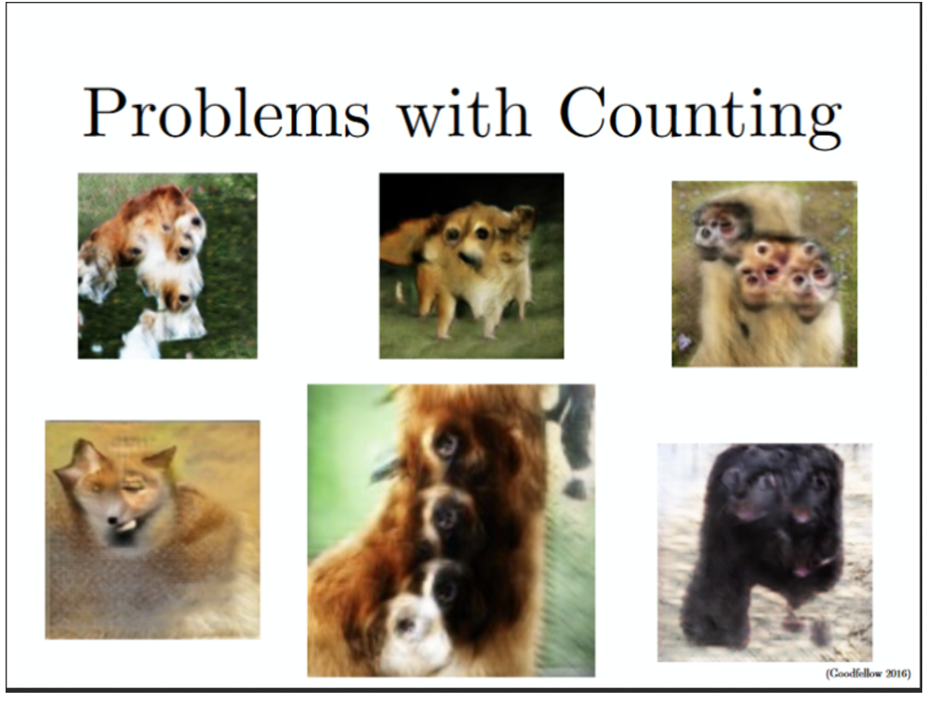

Source: NIPS 2016- arXiv: 1701.00160, 2017

B08086_01_41.png

## Problems with Perspective

GANs sometime are not capable of differentiating between front and back view and hence fail to adapt well with 3D objects while generating 2D representation from it as shown below.

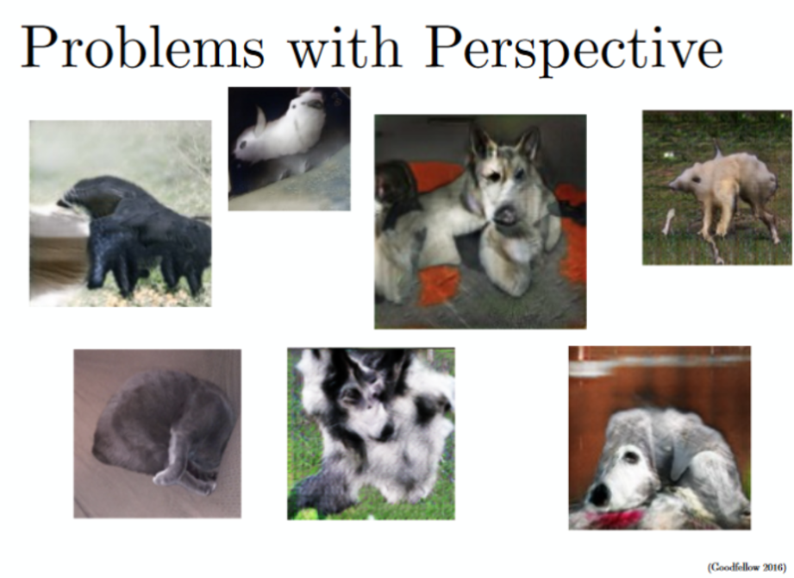

Source: NIPS 2016- arXiv: 1701.00160, 2017

B08086_01_42.png

## Problems with Global Structures

GANs do not understand a holistic structure similar to problem with perspective. For example, in the bottom left image, it generates an image of a quadruple cow, i.e. a cow standing on its hind legs and simultaneously on all four legs. That is definitely unrealistic and not possible in real life!

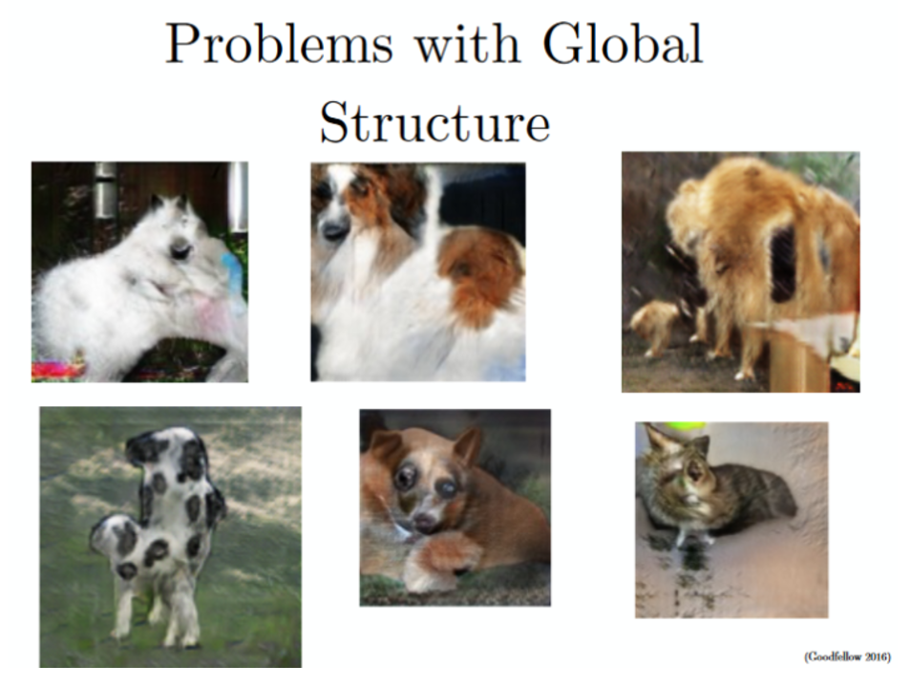

Source: NIPS 2016- arXiv: 1701.00160, 2017

B08086_01_43.png

# Improved training approaches and tips for GAN

## In order to overcome the difficulties of GAN models, deep learning practitioners carry out various hacks depending on the nature of the problem. Some of the improvisation techniques are mentioned below.

## Feature matching

The instability of GANs is addressed GANs by specifying a new objective for the generator that prevents it from overtraining on the current discriminator.

The idea is to use the features at the intermediate layers in the discriminator to match for real and fake images and make this as a supervisory signal to train the generator.

Specifically, we train the generator to generate data that matches the statistics of the real data, and match the expected value of the features on an intermediate layer of the discriminator. By training the discriminator we ask it to find those features that are most discriminative of real data versus data generated by the current model.

## Mini Batch

The problem of Mode collapse can be addressed by adding some extra features to the discriminator where the discriminator actually looks at an entire “mini batch of samples” at a time rather than looking at a single sample. If those features measure things like distance to other samples, then the discriminator can detect if the generator is starting to collapse in this way instead of encouraging every sample from the generator to move toward the single most likely point. The mini batch as a whole has to look realistic and have the correct amount of spacing between different samples.

## Historical averaging

The idea of historical averaging is to add a penalty term that punishes weights which are rather far away from their historical average values. For example, the cost is:

distance (current parameters, average of parameters over the last t batches)

## One-sided label smoothing

Usually one would use the labels 0 (image is real) and 1 (image is fake). Instead using some smoother labels (0.1 and 0.9) seems to make networks more resistant to adversarial examples.

## Normalize the inputs

Most of the time it is good to normalize the images between -1 and 1 and use Tanh as the last layer of the generator output.

## Batch Norm

The idea is to construct different mini-batches for real and fake, i.e. each mini-batch need to contain only all real images or all generated images. But when batch-norm is not an option, you can use instance normalization (for each sample, subtract mean and divide by standard deviation).

## Avoid Sparse Gradients with ReLU, MaxPool

The stability of the GAN game suffers if you have sparse gradients. LeakyReLU is good fit for both Generator and Discriminator.

In case of down-sampling, use a combination of Average Pooling, Conv2d + stride, whereas for up-sampling, use the combination of PixelShuffle, ConvTranspose2d + stride.

PixelShuffle- arXiv: 1609.05158, 2016

## Optimizer and Noise

Use the ADAM Optimizer for Generator and SGD for discriminator. And provide noise in the form of dropout to several layers of Generator.

## Don’t balance loss through statistics only.

Instead have a principled approach to it, rather than intuition.

while lossD > A:

train D

while lossG > B:

train G

Note- Despite all these tips and training enhancement steps, Generative Adversarial model is still relatively new in the field of AI and deep learning and so like any other fast growing field, it too requires a lot of improvement.

# Summary

So far you have learned how deep networks has evolved from the arena of supervised task of classifying an image, recognizing voice, text etc. towards the unsupervised field with lots of creative power through the concepts of Generative Adversarial Network. You have already generated some realistic images like handwritten digits, airplane, cars, birds etc using mnist, cifar datasets. Also, you have understood various challenges related to generative adversarial network and how to overcome it with practical tuning tips.

In the next few chapters we will continue our journey with different variety of GAN based architecture to perform some magnificent task with real datasets.